

ALLIANCE GIRLS 2025 PREDICTION
POSSIBLE KCSE EXAM
443/2
AGRICULTURE
PAPER 2
TIME: 2 HOURS

NAME……………………………………………………………………………………….
SCHOOL……………………………………………… SIGN………………………..
INDEX NO……………………………………………. ADM NO……………………
Kenya Certificate of Secondary Education.
INSTRUCTION TO CANDIDATES
- Write your name and index number and school, Sign and write the date in the spaces provided above.
- This paper consists of THREE sections; A, B and C.
- Answer All the questions in section A and B in the spaces provided and any TWO questions from section C in the answer sheet provided

FOR EXAMINERS USE ONLY
SECTION | QUESTION | MAXIMUM SCORE | CANDIDATE’S SCORE
A | 1 - 20 | 30
B | 21 - 24 | 20
C | 25-27 | 40
TOTAL SCORE |  | 90

SECTION A (30 MARKS)
Answer all the question in this section in the spaces provided.
1. Explain the meaning of the following terms.
  - Raddling. (½mk)
………………………………………………………………………………………………………………………………………………………………………………………………
  - Farrowing. (½mk)
………………………………………………………………………………………………………………………………………………………………………………………………
  - Caponisation (½mk)
………………………………………………………………………………………………………………………………………………………………………………………………
  - Gutting. (½mk)
………………………………………………………………………………………………………………………………………………………………………………………………

- What do the figures 3.3.3 in pig production stand for? (1mk)
………………………………………………………………………………………………………………………………………………………………………………………………………………………………………………………………………………………………………

3. Name any two tools in the farm that can be used to sharpen a blunt panga (1mk)
……………………………………………………………………………………………………………………………………………………………………………………

4. Name two livestock diseases prevented by use of the vaccine blanthrax. (1mk)
………………………………………………………………………………………………………………………………………………………………………………………………………………………………………………………………………………………………………

5. State any four mechanical methods of controlling ticks. (2mks)
………………………………………………………………………………………………………………………………………………………………………………………………
………………………………………………………………………………………………………………………………………………………………………………………………

6. List any four farm structures a dairy cattle farmer may have in the farm. (2mks)
………………………………………………………………………………………………………………………………………………………………………………………………
………………………………………………………………………………………………
………………………………………………………………………………………………

7. State two disadvantages of using a barbed wire fence in sheep rearing. (1mk)
………………………………………………………………………………………………………………………………………………………………………………………………

8. State four characteristics of an effective acaricide. (2mks)
………………………………………………………………………………………………………………………………………………………………………………………………
………………………………………………………………………………………….……
………………………………………………………………………………………………

9. State any four factors that affect the digestibility of feeds in an animal. (2mks)
………………………………………………………………………………………………………………………………………………………………………………………………
……………………………………………………………………………………….………
…………………………………………………………………………………….…………

10. Distinguish between mothering ability and prolificacy. (1mk)
………………………………………………………………………………………………………………………………………………………………………………………………
………………………………………………………………………………………….……
11. State four characteristics of succulent roughage feedstuffs. (2mks)
………………………………………………………………………………………………
…………………………………………………………………………………………………………………………………………………………………………………………….…
……………………………………………………………………………………………….

12. State four advantages of inbreeding. (2mks)
………………………………………………………………………………………………………………………………………………………………………………………………………………………………………………………………………………………………
………………………………………………………………………………………………

13. Identify the breed of pig that has the following features.
-Broad and slightly dished snout.
- Has a white skin.
- Has upright ears.

Identity (1mk)
………………………………………………………………………………………………

14. Name two methods used in castration of farm animals. (1mk)
………………………………………………………………………………………………………………………………………………………………………………………………………………………………………………………………………………………………

15. State four causes of stress in poultry. (2mks)
………………………………………………………………………………………………………………………………………………………………………………………………………………………………………………………………………………………………
………………………………………………………………………………………………

16. List any two construction materials required in the construction of a green house. (1mk)
……………………………………………………………………………………………………………………………………………………………………………………

17. Name any two sheep breeds kept for production of meat. (1mk)
……………………………………………………………………………………………………………………………………………………………………………………

- State how the following conditions are achieved in a calf pen.

a) Draught free. (½mk)
…………………………………………………………………………………………
b) Proper lighting (½mk)
…………………………………………………………………………………………

- State the functions of the following parts of a plunge dip

a) Drying yard. (1mk)
……………………………………………………………………………………………………………………………………………………………………………………
b) Foot bath. (1mk)
…………………………………………………………………………………………………………………………………………………………………………………...

20. State four uses of a crush. (2mks)
……………………………………………………………………………………………………………………………………………………………………………………
…………………………………………………………………………………………
…………………………………………………………………………………………

SECTION B 20 MARKS
Answer all questions in this section in the spaces provided.
- The diagram below represents an external parasite. Study carefully and use it to answer the questions that follow.
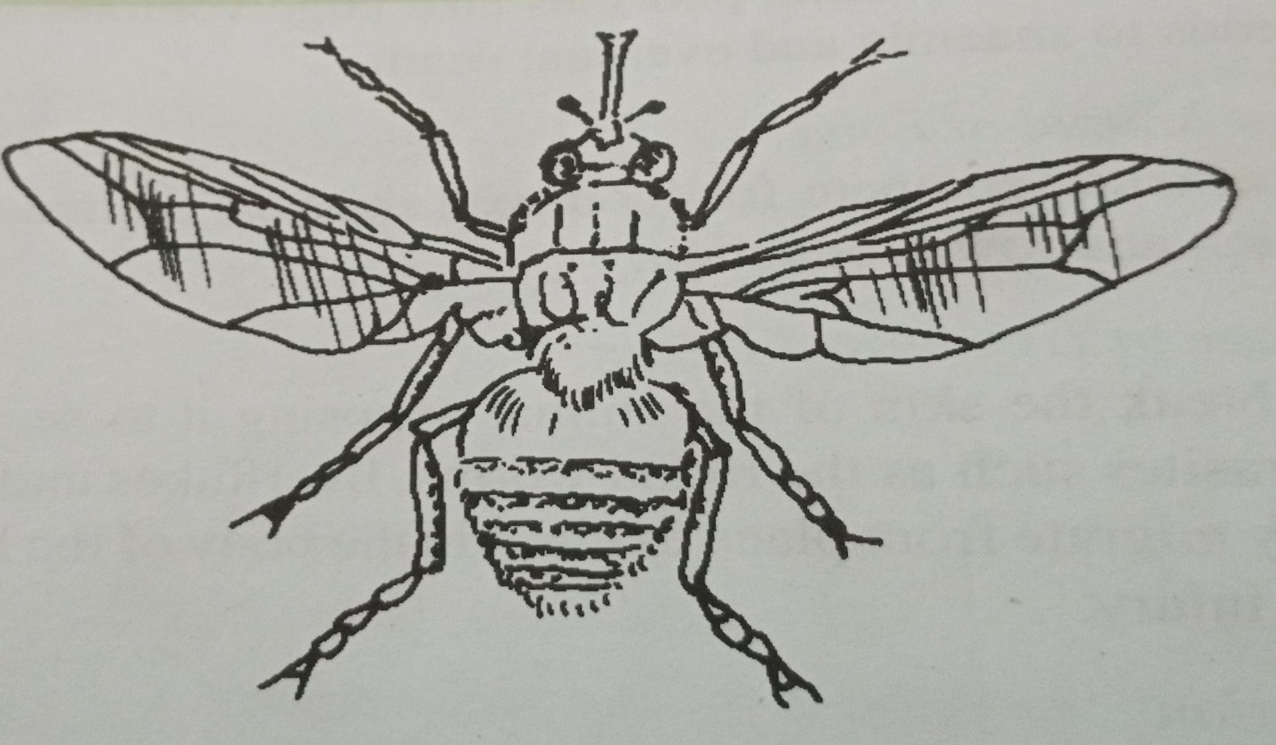

a) Identify the parasite above. (1mk)
………………………………………………………………………………………………

b) State any two harmful effects of the parasite above. (2mks)
………………………………………………………………………………………………………………………………………………………………………………………………

c) State any two control measures for the parasite above. (2mks)
………………………………………………………………………………………………………………………………………………………………………………………………

22. The diagram below shows a routine practice being carried out on an animal. Study it and answer the question that follows.
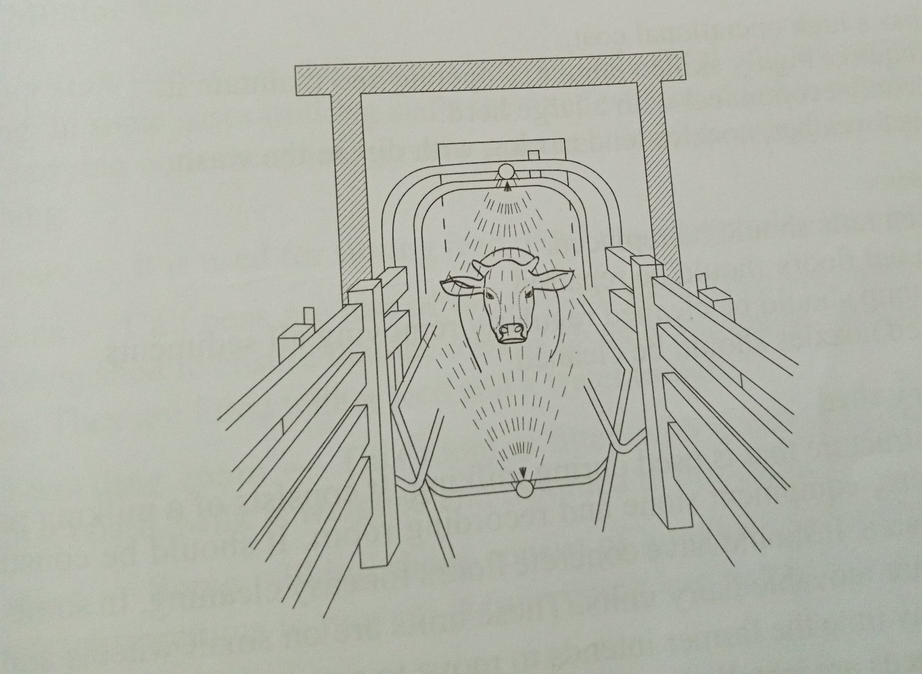
a) Identify the practice. (1mk)
…………………………………………………………………………………………………
b) Name the structure in which the practice is being carried out. (1mk)
…………………………………………………………………………………………………
c) State three advantages of using the above structure instead of a plunge dip. (3mks)
………………………………………………………………………………………………………………………………………………………………………………………………………………………………………………………………………………………………………
…………………………………………………………………………………………………

23. Below is a diagram of a cow suffering from a deficiency disease. Study it and answer the questions that follow.
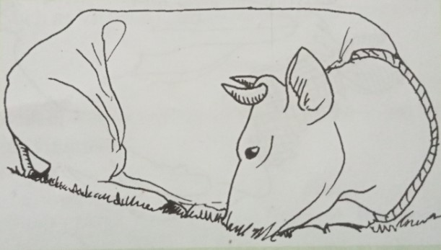
a) Identify the disease the animal is suffering from. (1mk)
……………………………………………………………………………………………

- State the cause of the disease. (1mk)
…………………………………………………………………………………………………………………………………………………………………………………………

- List any three symptoms of the above disease. (3mks)
………………………………………………………………………………………………………………………………………………………………………………………… ……………………………………………………………………………………………
4. The diagram below represents farm tools and equipment. Study and answer the questions that follow.
B
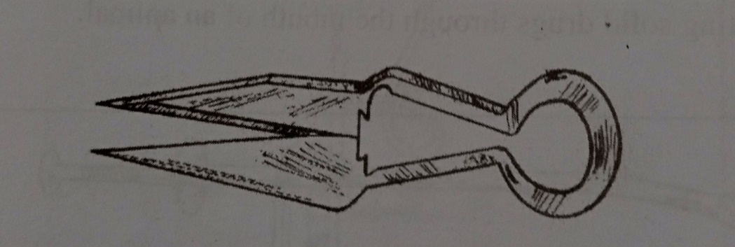
A
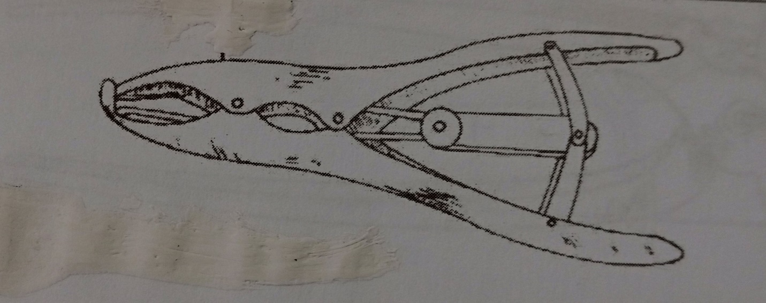
- Identify the tools labeled A, and B. (2mks) A:………………………………………………………………………………………
B………………………………………………………………………………………

- State one use of each of the tools labeled A and B. (2mks)
A:……………………………………………………………………………………………

B:……………………………………………………………………………………………
- State one maintenance practice for the tool labeled A. (1mk)
……………………………………………………………………………………………………………………………………………………………………………………

SECTION C (40 MARKS)
Answer any two questions in this section in the spaces provided

25.a) Discuss New castle disease under the following sub headings.
(i) Causal organism. (1mk)
(ii) Animals attacked. (1mk)
(iii) Symptoms of attack. (5mks)
(iv) Control measures. (3mks)

b) Outline the characteristics of indigenous cattle breeds. (5mks)
c) Describe five microbial activities that take place in the rumen of ruminant
animals. (5mks)

26.a) State and explain any five predisposing factors of livestock diseases. (10mks)
b) Describe the procedure of constructing a barbed wire fence. (5mks)
c) Outline any five general functions of vitamins in livestock. (5mks)

27.a) Discuss any five essentials of clean milk production. (10mks)
b) Describe the process of egg formation in the reproductive system of a hen. (10mks)

